# Create a dictionary for student database and perform following operations.

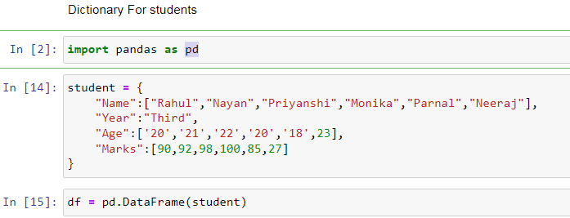

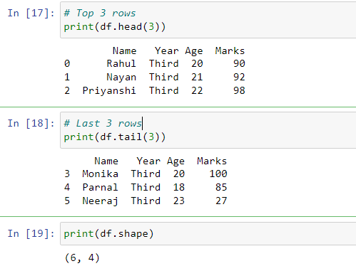

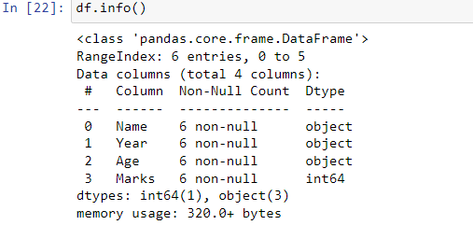

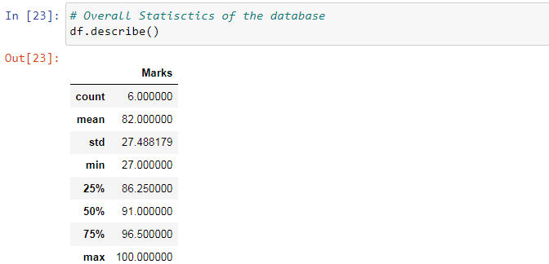

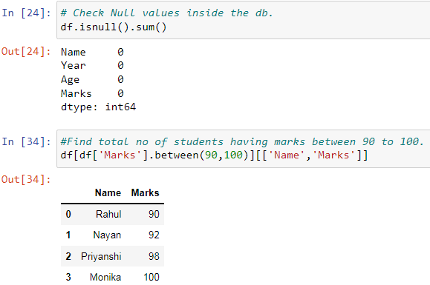

# 2.Perform following operation on Ecommerce purchase website

1. Display Top 10 Rows of The Dataset 2. Display last 10 rows of dataset.

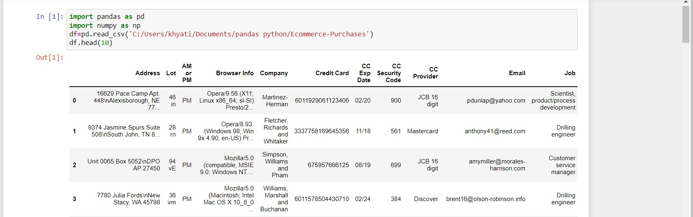

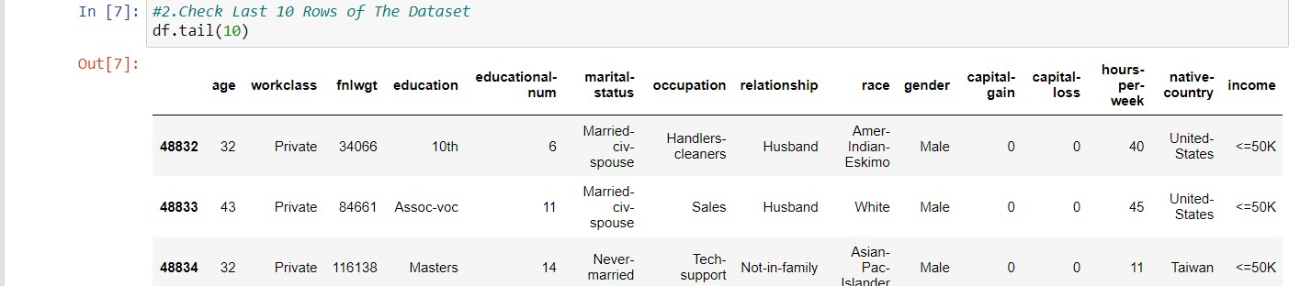

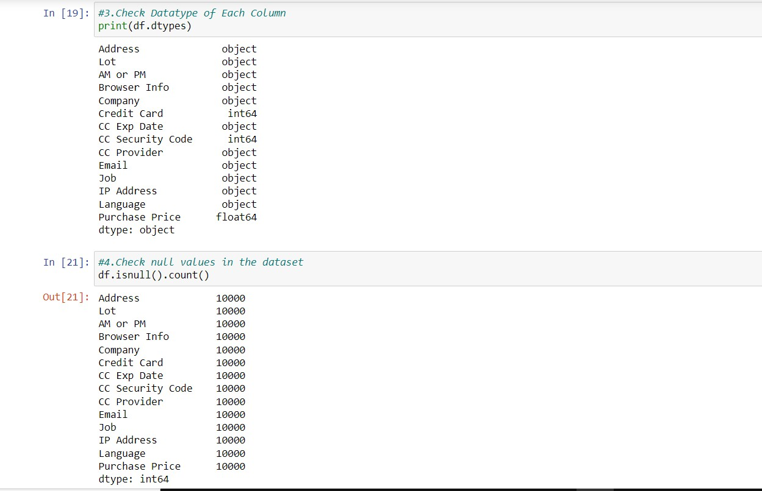3. Check Datatype of Each Column 4. Check null values in the dataset

5. How many rows and columns are there in our Dataset? 6. Highest and Lowest Purchase Prices.

7. Average Purchase Price 8. How many people have French 'fr' as their Language?

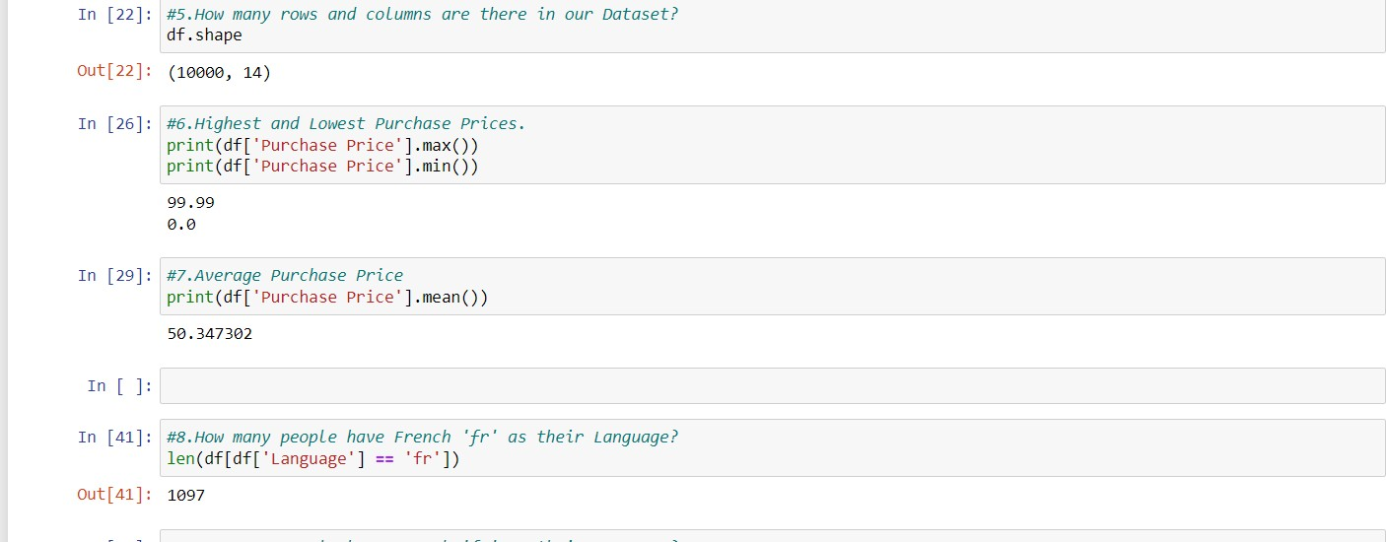

1. **Job Title Contains Engineer**
2. **Find The Email of the person with the following IP Address: 132.207.160.22 11. How many People have Mastercard as their Credit Card Provider and made a purchase above 50.?**

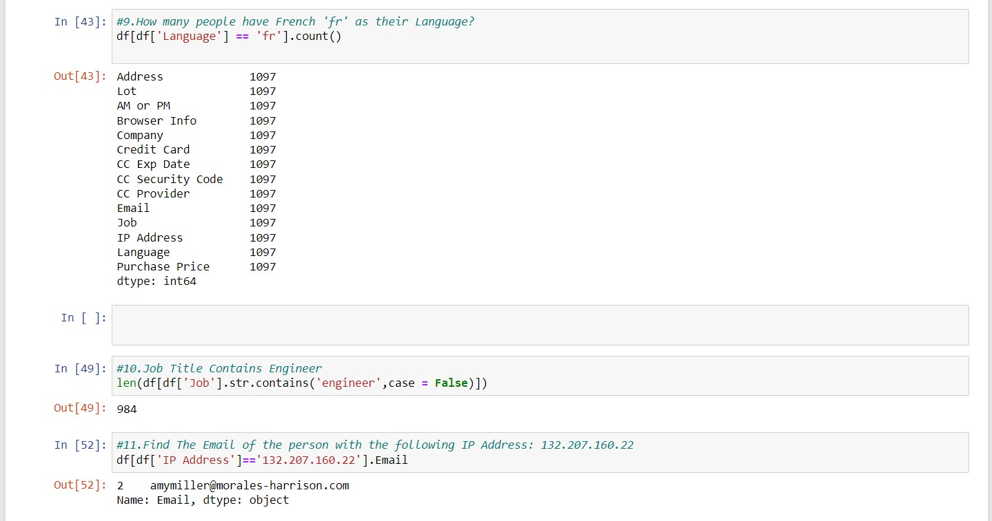

1. **Find the email of the person with the following Credit Card Number: 4664825258997302**
2. **How many people purchase during the AM and how many people purchase during PM?**
3. **How many people have a credit card that expires in 2020?**
4. **What are the top 5 most popular email providers (e.g. gmail.com, yahoo.com, etc...)**

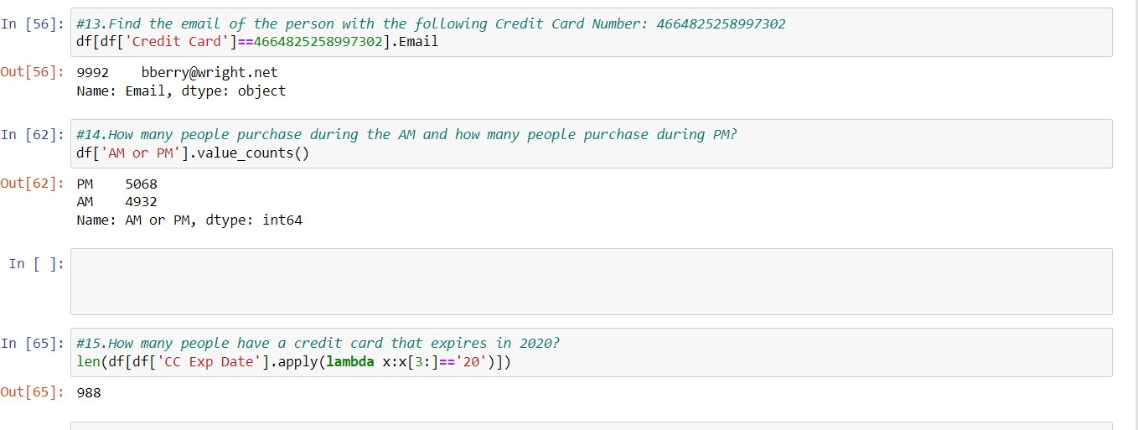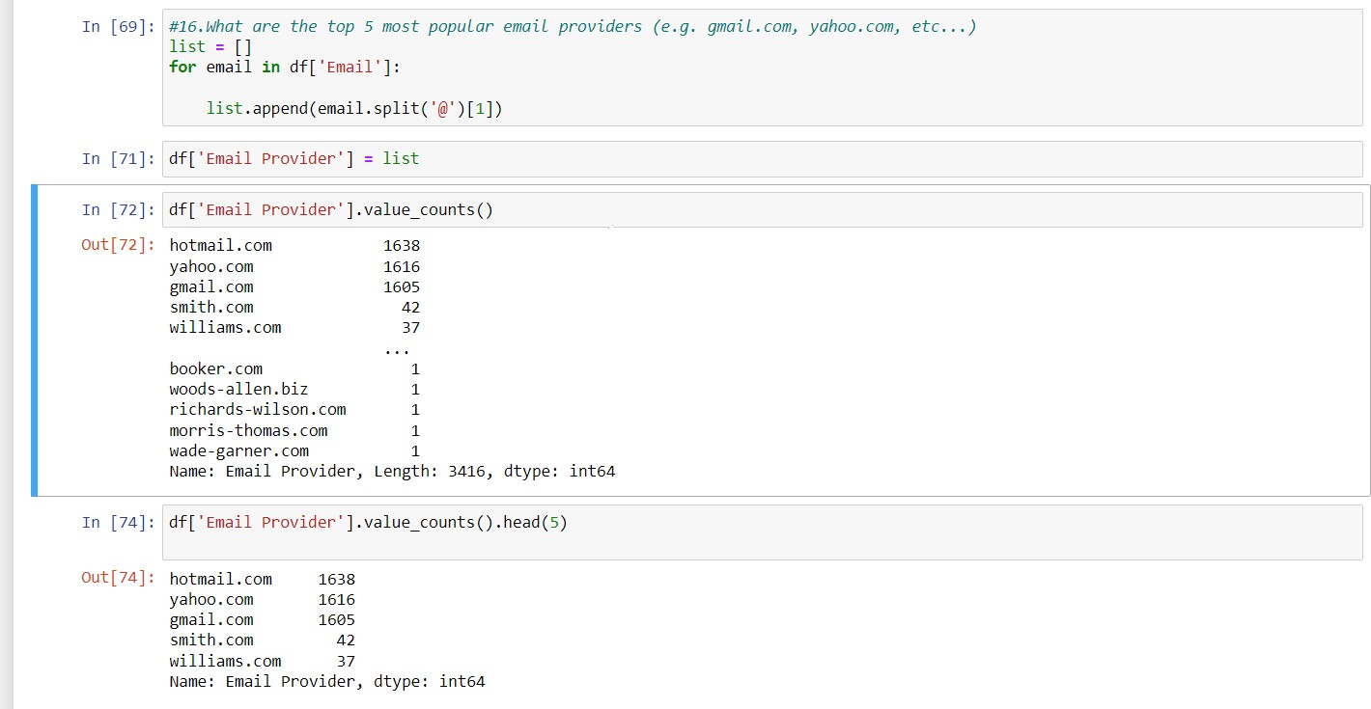

# .Perform following operation on Employee salary dataset

1. **Getting Information About Our Dataset Like Total Number Rows, Total Number of Columns, Datatypes of Each Column And Memory Requirement**

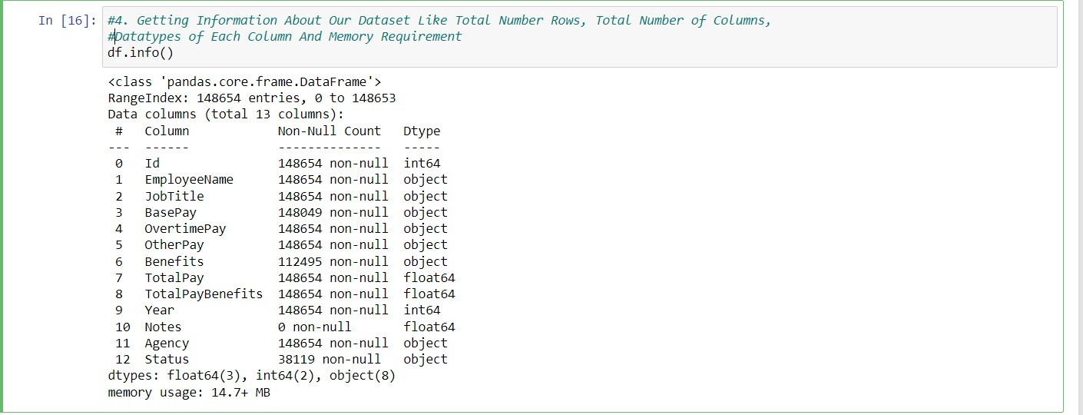

1. 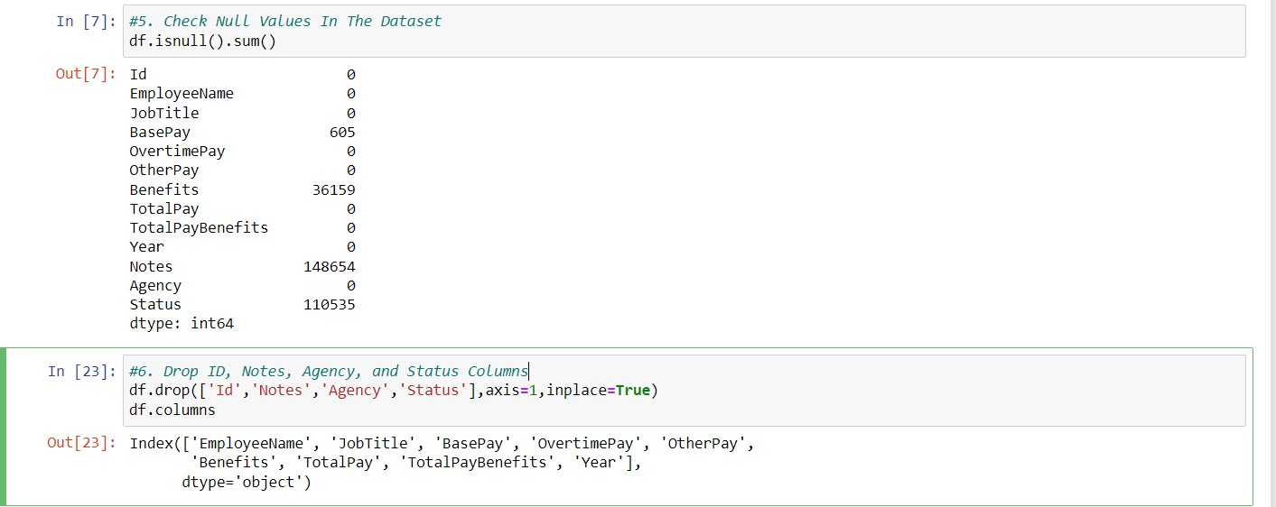**Check Null Values In The Dataset 6. Drop ID, Notes, Agency, and Status Columns**

**7. Get Overall Statistics About The Dataframe 8. Find Occurrence of The Employee Names (Top 5) 9. Find The Number of Unique Job Titles**

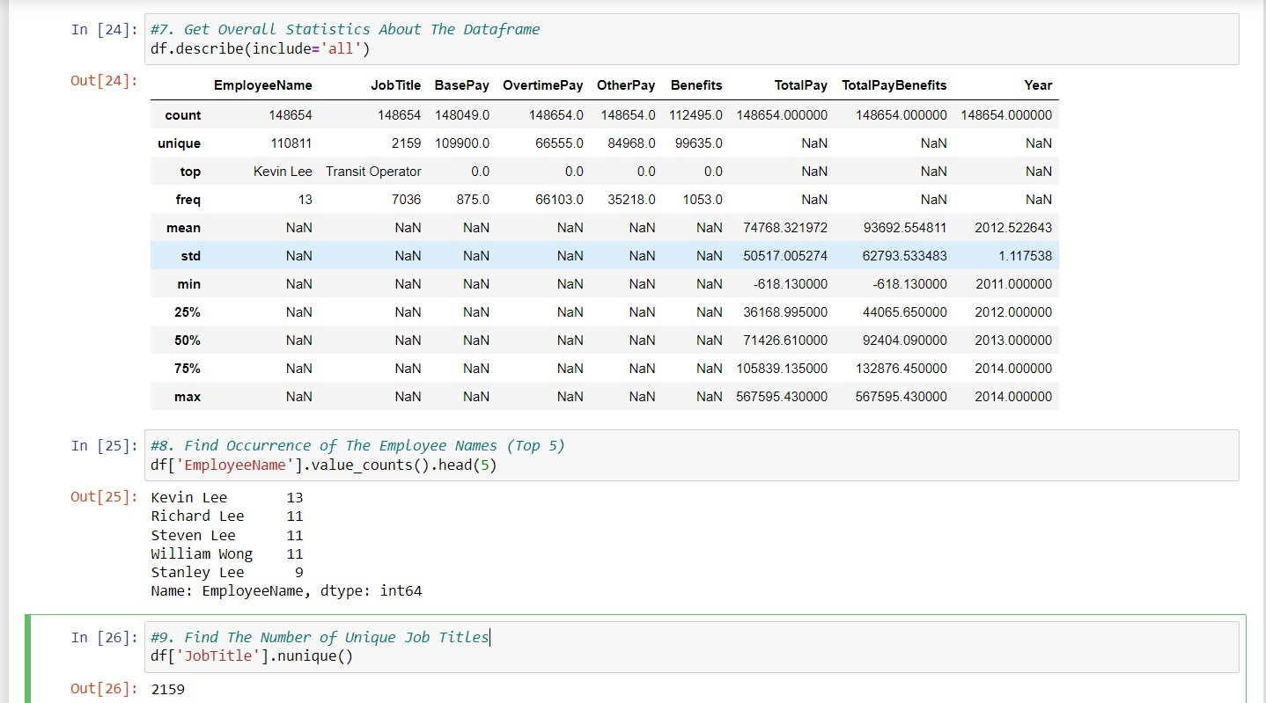

1. **Total Number of Job Titles Contain Captain**
2. **Display All the Employee Names From Fire Department**

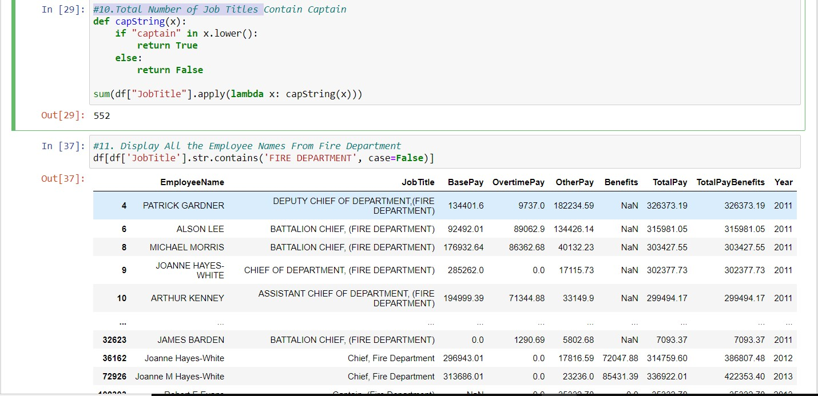

**Find Minimum, Maximum, and Average BasePay 13. Replace 'Not Provided' in EmployeeName' Column to NaN**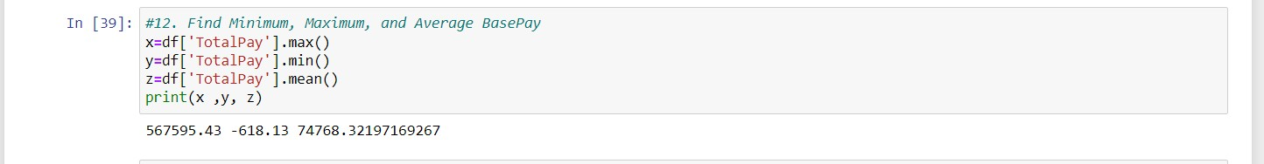

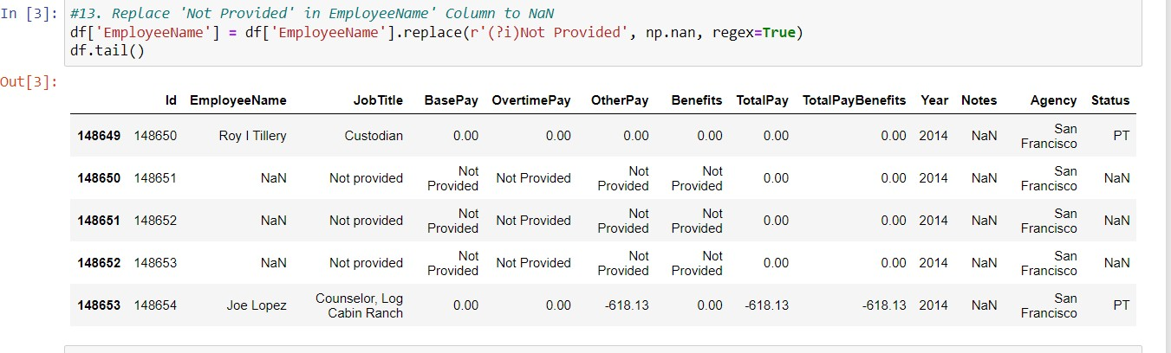

**14. Drop The Rows Having 5 Missing Values 15. Find Job Title of ALBERT PARDINI**

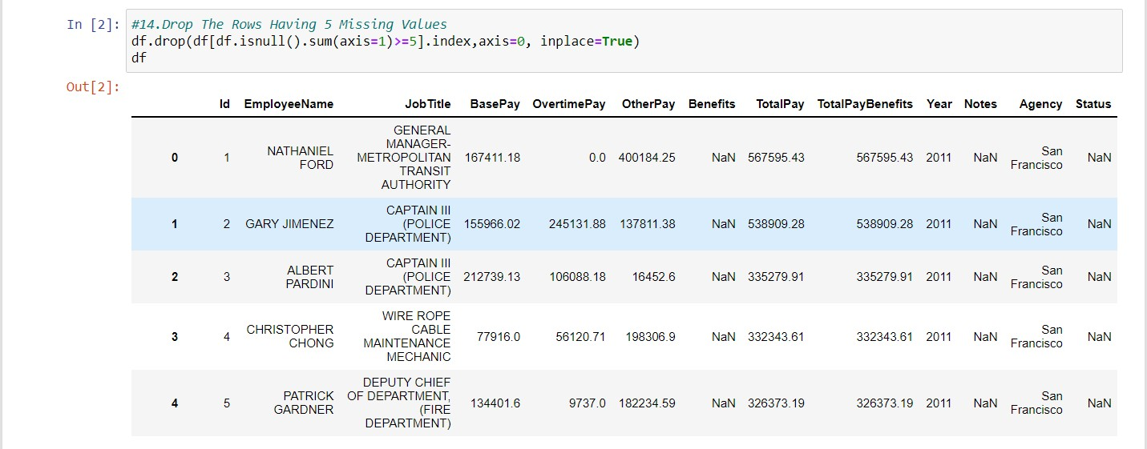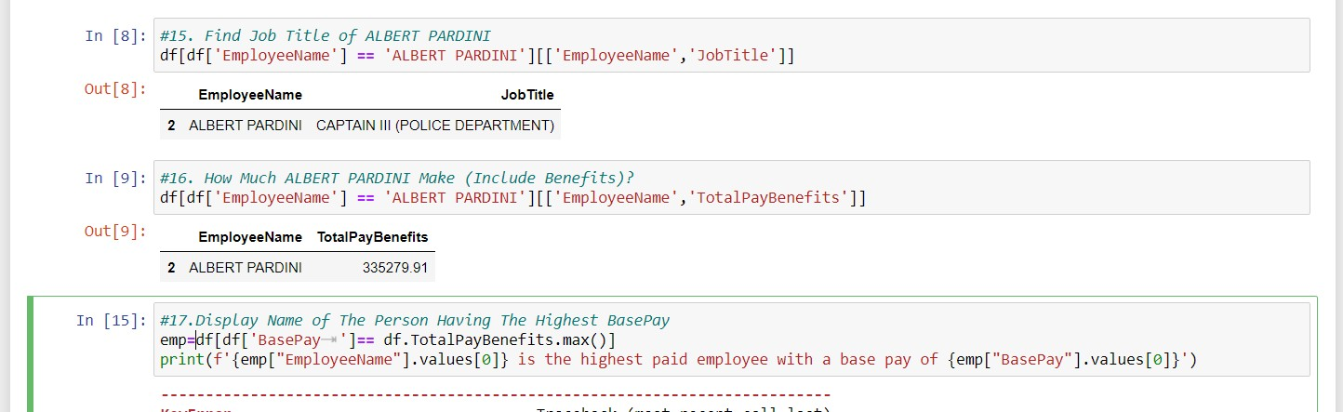**16. How Much ALBERT PARDINI Make (Include Benefits)? 17.Display Name of The Person Having The Highest BasePay.**

**21. Find Top 5 Most Common Jobs**

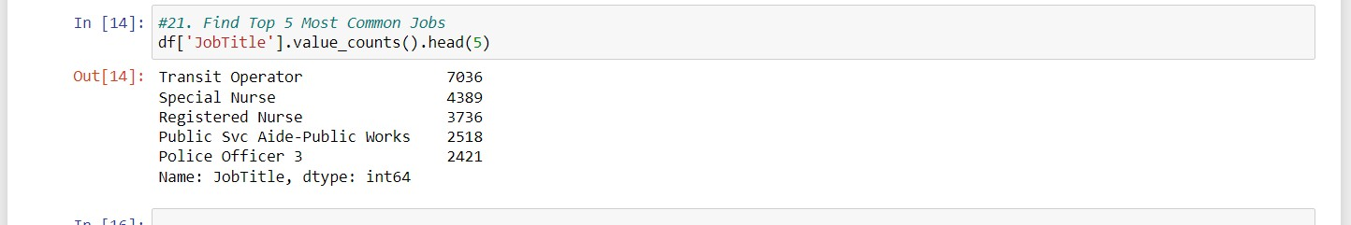

# 4 .Perform following operation on Income Database .

1. 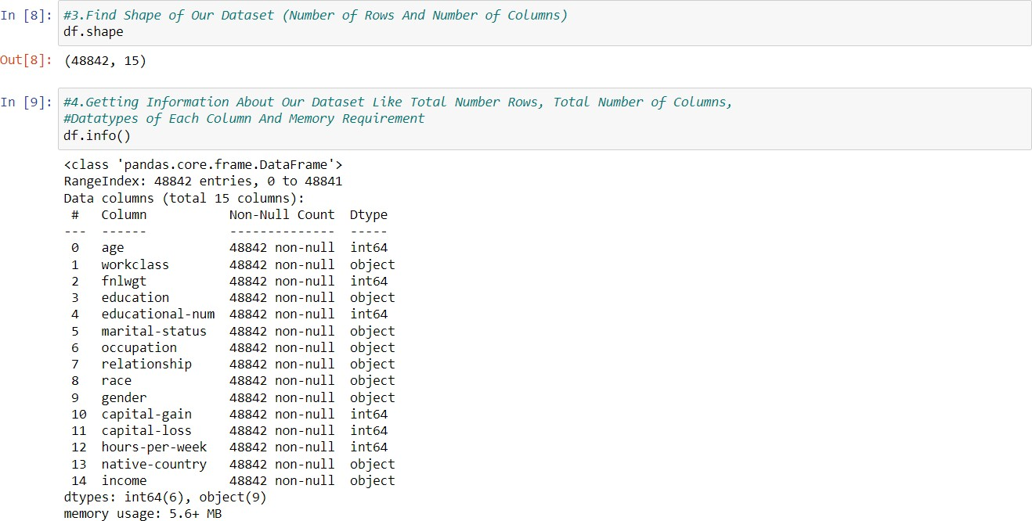**Getting Information About Our Dataset Like Total Number Rows, Total Number of Columns,Datatypes of Each Column And Memory Requirement**
2. 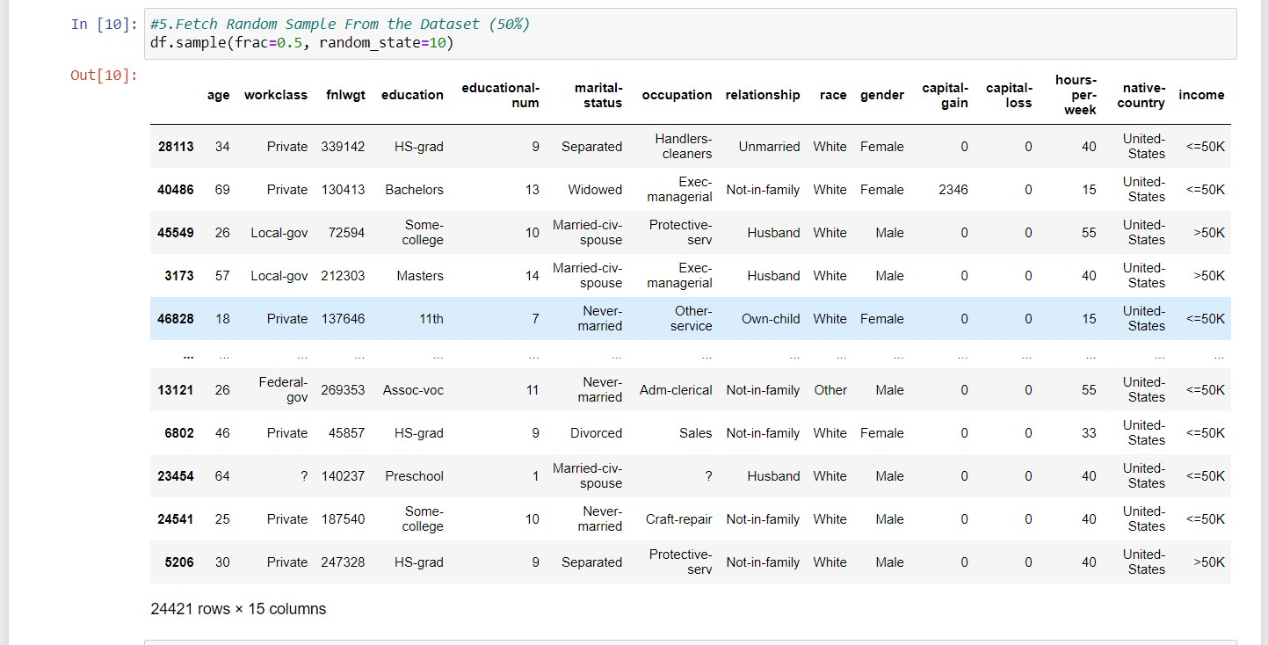**Fetch Random Sample From the Dataset (50%) ,Check Null Values In The Dataset** .

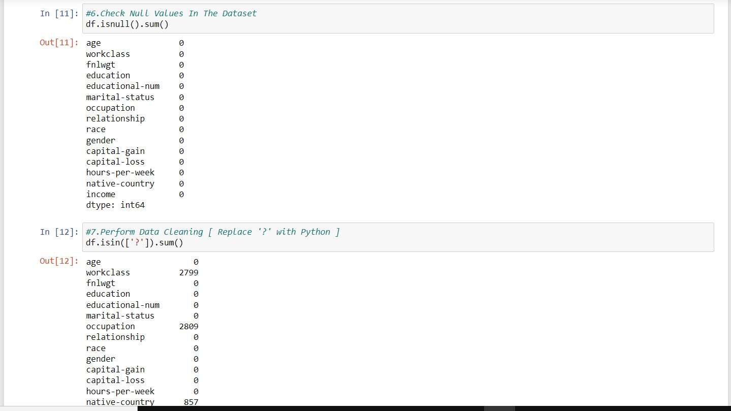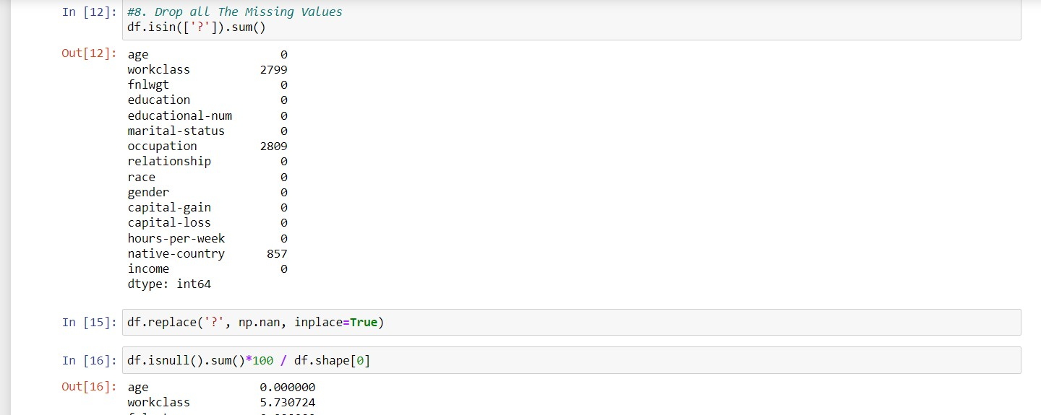

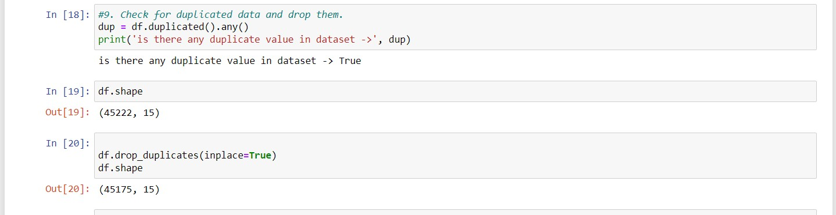

1. **Get Overall Statistics About The Dataframe**
2. **Drop The Columns education-num, capital-gain, and capital-loss**
3. **What Is The Distribution of Age Column?**
4. **1.Find Total Number of Persons Having Age Between 17 To 48**

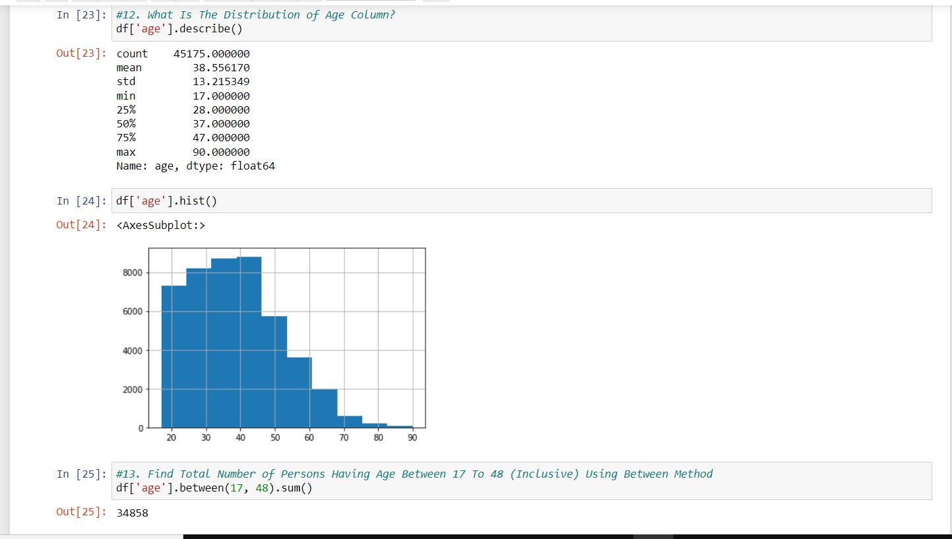

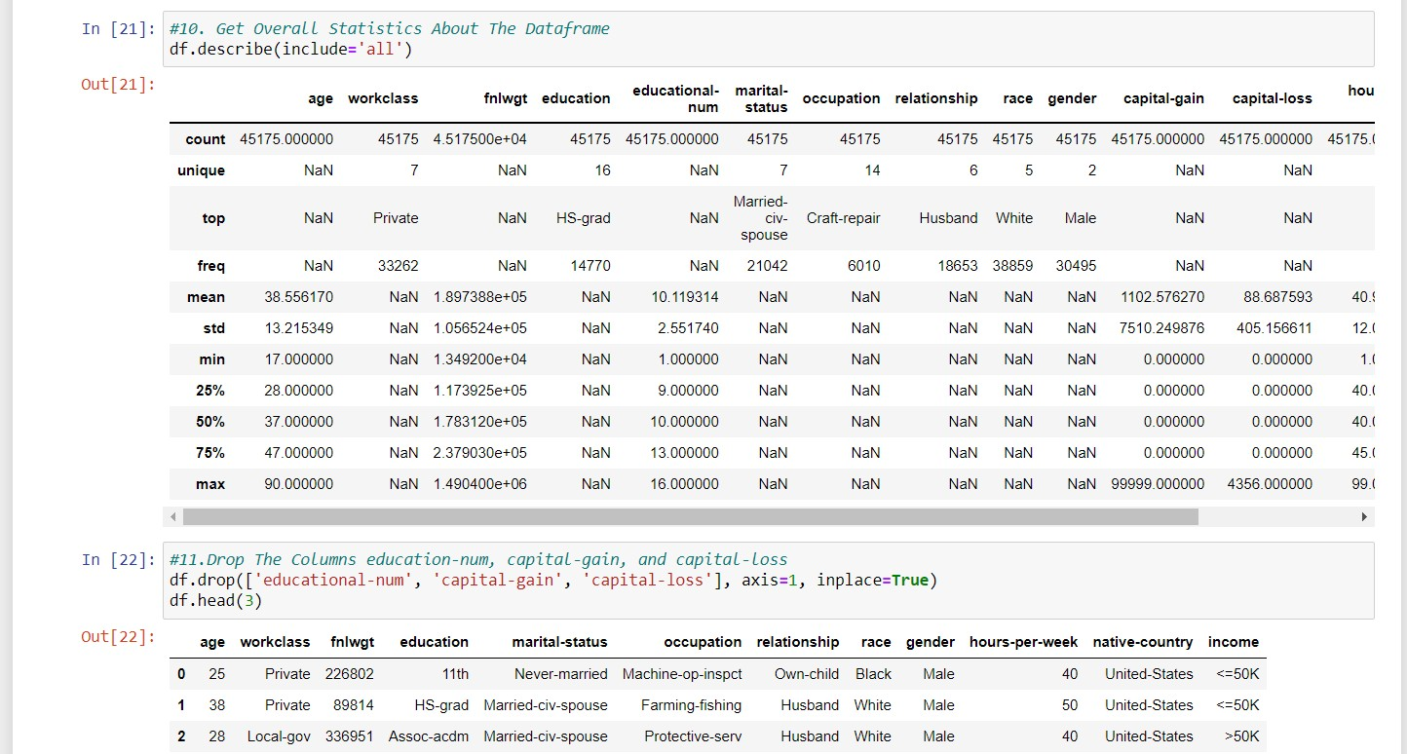

1. **What is The Distribution of Workclass Column? 15. How Many Persons Having Bachelors and Masters Degree? 16. Bivariate Analsis**
2. **Replace Salary Values With 0 and 1**

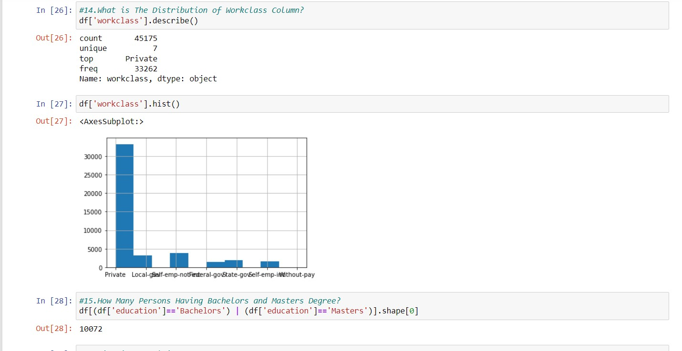

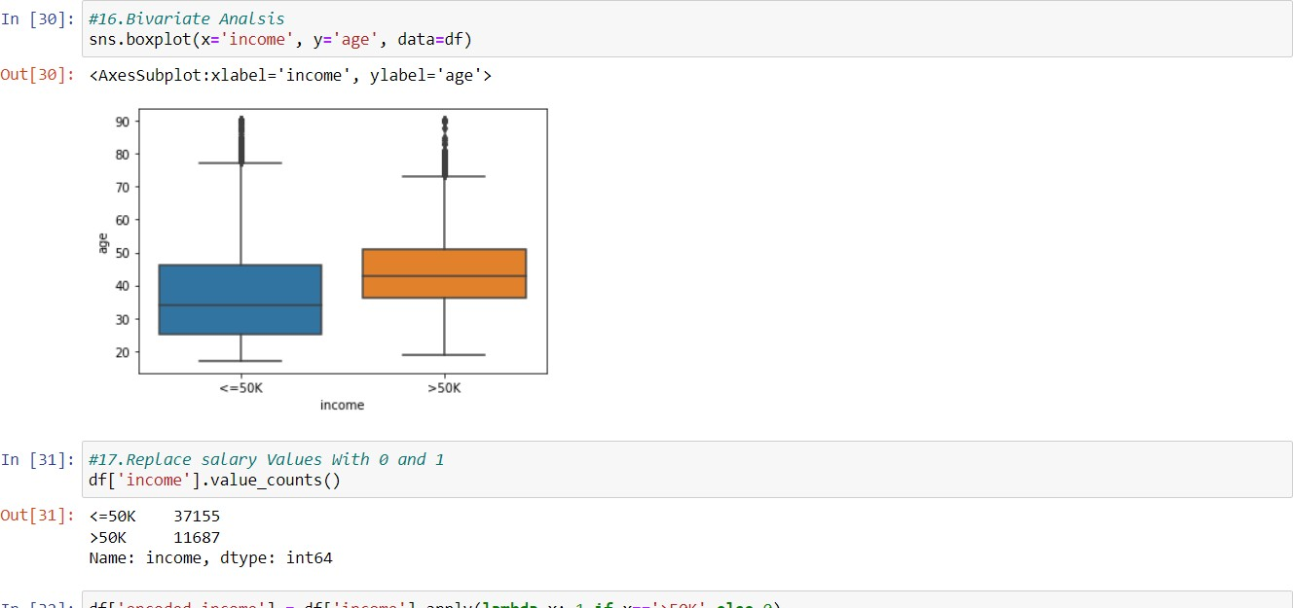

1. **Which Workclass Getting The Highest Salary?**
2. **How Has Better Chance To Get Salary greater than 50K Male or Female.**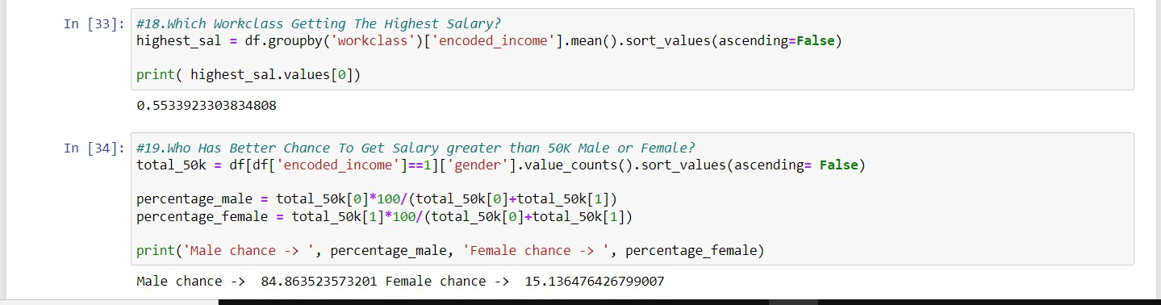
3. **Convert Workclass columns datatype into category datatype.**

